CLIP Connection: Students will use journaling to explain and reflect on concepts in Mathematics.
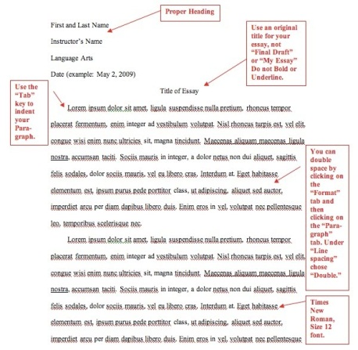
Starting tomorrow, your journal entries will be uploaded electronically using turnitin. The journal topics for the remainder of the quarter are listed (two entries per week). Your entries should be submitted on time and in MLA format. Although you may be able to submit your entries after the due date, there will be a ten point per day deduction. Also, make sure your journal entries from last week are completed.
Sign into turnitin.com:
Go to http://www.turnitin.com/
Click “create an account”
Click “Student”
Enter Class ID (See table below)
Enter Class Enrollment Password (See table below)
Complete the personal information

 | Class ID | Class Enrollment Password
First Period | 10458390 | richmond1
Second Period | 10458397 | richmond2
Third Period | 10458407 | richmond3
Fourth Period | 10458373 | richmond4
Sixth Period | 10454676 | richmond6
Seventh Period | 10458431 | richmond7

Your entries can be uploaded from a computer, flash drive, google drive, dropbox, etc.

